**Chapter 5 exercise – installing the AD DS and DNS roles and promoting the server to a DC**

In this chapter exercise, you will learn how to install the AD DS and DNS roles and promote the server to a DC.

**Installing the AD DS and DNS roles, and**

## promoting the server to a DC

To install the AD DS role in Windows Server 2019, complete the following steps:

1. Click the **Start** button, and then, in the **Start** menu, click the **Server Manager** tile.
2. In the **Server Manager** window, in the **WELCOME TO SERVER MANAGER** section, click **Add roles and features**, as shown in *Figure 5.27*:

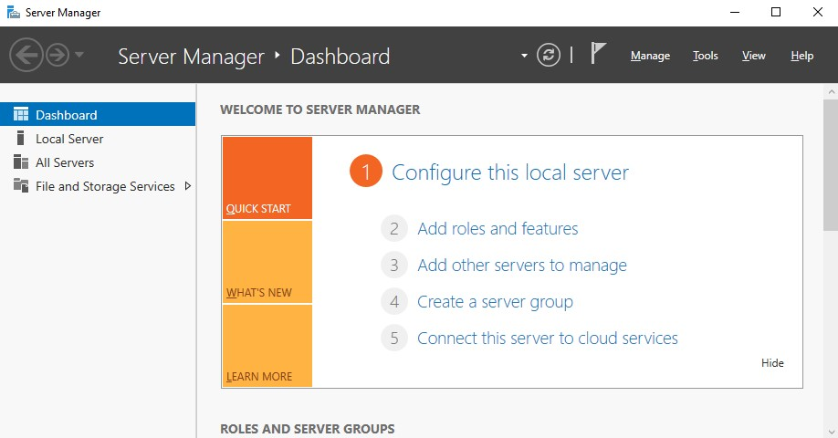

Figure 5.27: Adding roles and features to the server using Server Manager

1. With the **Add Roles and Features** **Wizard** open, click **Next**.
2. Select the **Role-based or feature-based installation** option and click **Next**.
3. With the **Select a server from the server pool** option checked, click **Next**.
4. Select the **Active Directory Domain Services** role, as shown in *Figure 5.28*, and then click **Next**:

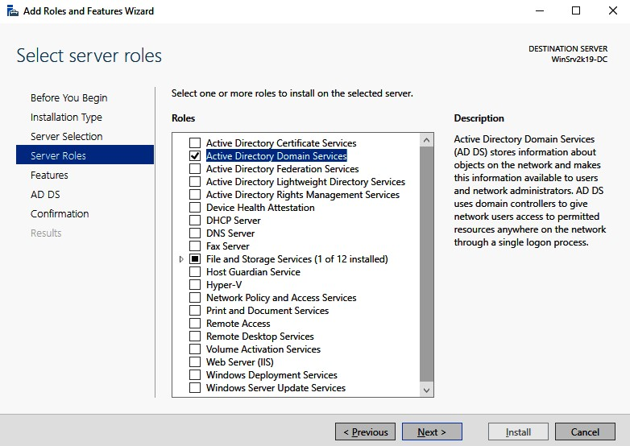

Figure 5.28: Add Roles and Features Wizard in Windows Server 2019

1. Click the **Add Features** button when the **Add features that are required for Active Directory Domain Services?** window is displayed. Click **Next**.
2. Accept the default settings in the **Select features** step and click **Next**.
3. Take your time to read the AD DS description and the things to note regarding AD DS installation. Then, click **Next**.
4. Confirm the installation selections for the AD DS role and click the **Install** button.
5. Either hit **Close** or wait until the installation progress reaches its end.
6. Click **Close** to close the **Add Roles and Features** **Wizard***.*
7. In **Notifications**, click **Promote this server to a domain controller**.
8. In the AD DS configuration wizard*,* select the **Add a new forest** option, as shown in *Figure 5.29*, and then enter **Root domain name mydomain.local**. Click **Next**:

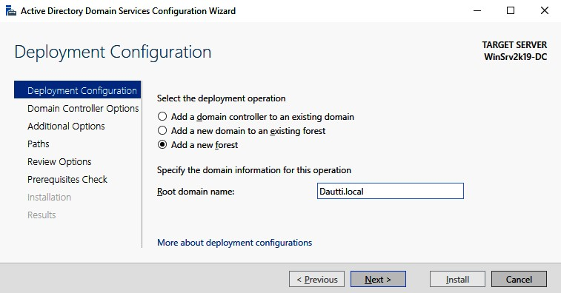

Figure 5.29: AD DS configuration wizard

1. Accept the defaults for the forest and domain functional levels, and enter the **Directory Services Restore Mode** (**DSRM**) password. Click **Next**.
2. If you have an existing DNS on your network, manually create a delegation for that DNS server to enable reliable name resolution from outside of your domain. Otherwise, no action is required. Click **Next**.
3. Either accept the default NetBIOS entry or change it accordingly. Click **Next**.
4. Either accept the default paths or change them accordingly. Click **Next**.
5. Review your options and click **Next**.
6. Since the prerequisites are met, click **Install**.
7. The server will restart to complete promoting itself to a DC.